The UX of Health Insurance

The state of South African Health Insurance
Websites in 2020

Part 3 of 4

This is Part 3 in a series of 4, where we explore the usability and patient experience across the websites of the most popular Medical Aid companies in South Africa. You can find Part 2 here.

If you’re in a rush…

- Our team of design experts assessed 16 healthcare provider’s websites against a set of usability standards in the Cognitive Walkthrough phase of The Sand Dollar Design Heuristic Framework.
- There are common customer journeys that if considered and simplified will make healthcare websites easier to use.
- We found that many health insurance websites make it easy for people to sign-up for a medical aid plan, however things start to get cumbersome and confusing once people start wanting to take advantage of their benefits.

Intro

In Part 3 of our series on the state of South African Medical Aid Websites in 2020, we will be sharing our insights from the Cognitive Walkthrough that we conducted.

Cognitive walkthroughs are used to examine the usability of a product. They are designed to see whether or not a new user can easily carry out common tasks associated with a product. At each step through the dialogue, usability experts will check to see if the simulated user's goals and memory content can be assumed to lead to the next correct action.

Who did we evaluate?

Our team of researchers evaluated the websites of (alphabetical):
Affinity Health, Bestmed, Bonitas, Discovery Health, Fedhealth, GEMS, Genesis, Medihelp, Medshield, Momentum, Polmed, Profmed, Selfmed, Umvuzo, United Healthcare and Vitality.

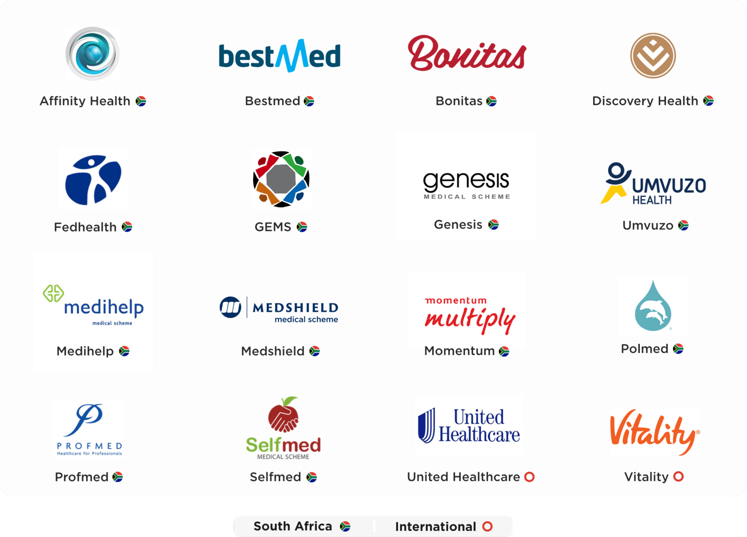

What was our method of evaluation?

We assessed six tasks that a user of a healthcare insurance website may wish to achieve:
- Determine whether a dependent can go for an MRI on a certain plan.
- Move to another, more comprehensive, plan.
- Book an appointment with a GP covered by a certain medical aid plan.
- Read up about a certain medical aid plan's benefits.
- Submit a claim for a physiotherapist appointment.
- Join a medical aid plan.

Each of the aforementioned tasks were broken up into a series of a steps in which we put ourselves into the feet of the user by asking ourselves if the user will be able to:
- Achieve the right outcome.
- Notice that the correct action is available to them.
- Associate the correct action with the outcome they expect to achieve.
- If the correct action is performed; will the user see that progress is being made towards their intended outcome?

* Some information was hidden behind a login, however for the purpose of this assessment we tried to complete these tasks by using the information provided on each website.

What are our key insights?

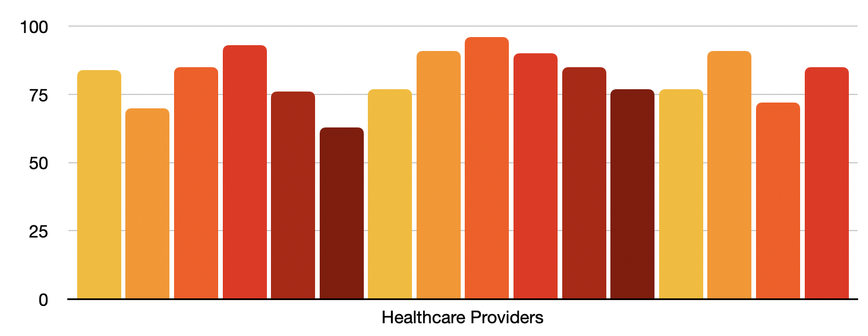
Figure 1: Graph that we used to track the overall success of each medical aid provider in achieving each task within our cognitive walkthrough.

We were able to identify the highest and lowest performing medical aid providers, as well as identify trends across the 16 providers that we assessed.

Highest performer

The healthcare provider that achieved the highest score did well in the following areas:

Well organised information architecture
Where you put your information and how easy it is to find is just as important as what information you choose to share. Most tasks could be easily started on this website by simply looking for a relevant section on the navigation bar.

Easy to sign-up or change plans
Signing-up or applying to upgrade a plan happens through a simple form, which can be found at the bottom on every page. This provider also offers a membership fee estimation tool which helps users determine more or less how much a specific medical aid plan will cost them per month.

Easy to find a doctor
For users wanting to book an appointment with a GP covered by their medical aid, it is important to be able to know which healthcare providers are available to them. This provider’s website gives users a form that, once filled in, will generate a list of relevant doctors to view or print.

Easy to find medical aid plan
A common requirement for people visiting a medical aid website is to be able to read about each medical aid plan's benefits. This website offers an overview of each plan right from the landing page. These overviews include a plan summary, monthly fee as well as a link to read more. This provider’s website saves users time by giving them the most important information in an easy to find way.

Lowest performer

For the healthcare provider that achieved the lowest score most tasks were difficult or impossible to complete.

Poorly designed homepage
A design that is unique or original isn’t necessarily useable. This healthcare provider’s homepage has a unique visual design but poor usability. The homepage looks interesting but breaks usability standards resulting in a difficult to navigate website. Usability standards such as Jacob Nielson’s Design Guidelines for Homepage Usability indicate that a good homepage should emphasise the highest priority tasks so that users have a clear starting point on the homepage. This website does not prioritise key tasks such as viewing medical aid plans and therefore doesn’t give users a clear starting point.

Critical information difficult to find
This healthcare provider requires users to download PDFs of for-print brochures in order to read up about each plan’s benefits. For the task of reading up about whether a dependent can go for an MRI on a certain plan, users will actually have to email the medical aid’s radiology authorisation department in order to find their answer as this information is not included in the PDFs.

Too many steps
In order for users to read up about their plan’s complete benefits they need navigate through a number of screens in order to find the information they are looking for. This is in stark contrast with the top performer, which outperformed this provider by 2.5x by streamlining the path to the websites most common actions and journeys.

Overall trends

We noticed that South African healthcare providers generally make it easy for people to sign-up for a medical aid plan, however things start to get cumbersome and confusing once people start wanting to take advantage of their benefits. We would recommend investing in streamlining the overall customer experience of the website, not just helping new users sign-up.

We know that customer retention is more cost effective than customer acquisition. With that in mind it makes sense to invest in understanding your existing customer’s needs, tasks and goals in order to design better solutions to keep your customers happy.

In summary

Medical aid providers who are learning from usability standards and streamlining common user journeys, such as the ones used in our assessment, have invested in a quality user experience for their customers. Providers who would like to increase their market share can do so by identifying their users and building digital offerings which meet or exceed those users’ needs.

Keep an eye out for the next instalment of The UX of Health Insurance 2020 research series with Part 4: Feature Inspection coming soon.

Find out more
If you are interested in more detailed insights and finding out more about this study, request a detailed report on our findings.

About Sand Dollar Design
Sand Dollar Design is an Experience Design Consulting firm, with a focus and passion for re-imagining the Patient and Provider experience through Digital Health interventions, in order to achieve improved Healthcare outcomes for all.
Find out more about our services at www.sanddollardesign.co

